Title: Fiscal Policy
Subject: EEP 14

1. Countercyclical policies  2. Problems of high deficits  a. Ex. the Political Business cycle  3. EMU fiscal Policy  A. Objectives  B. Maastricht  C. The need of the SGP (prevention)  E. Exceptions to the deficit level  F. What if non compliance?  4. Is the Eu the Optimal currency area?  5. Convergence criteria (entry conditions) to create syncronization  6. Results of EMU | In general, mp and fp should ensure the stabilization of the business cycle over time to foster consumption smoothing (countercyclical).  MORAL HAZARD  As financial mkts become integrated, the common cb might have an incentive not to let any country go bankrupt (by setting lower i or buying government bonds = They know cb will bail them out!!!). This may loosen the incentives for budget discipline in each country = moral hazard.  NEGATIVE SPILLOVERS  If one member state sincreases public debt=> negative spillover via crowding-out of private investment  CROWD OUT OF PUBLIC  High public deficits tend to crowd-out private investments in the economy (and hence reduce long term growth). Given same amount of resources, if more goes to government less goes to companies. In markets firms are in competition with governments.  HIGHER INFLATION  In the LR the discounted sum of Gov rev = discounted sum of Gov exp ( inter-temporal BC). Gov debt and mp are linked: printing money => π => the real burden of debt ↓. Hence if debt is high and the cb is not independent => high incentive for inflation  If an inflation target has to be achieved, debt needs to be balanced in the medium-run  Overall there is a clear need for stringent rules on budget discipline in a Monethary union. And yet we could ask ourself why countries do not self discipline themselves: why would a country accumulate unsustainable debt? fiscal illusion, political business cycle, coalition govenments  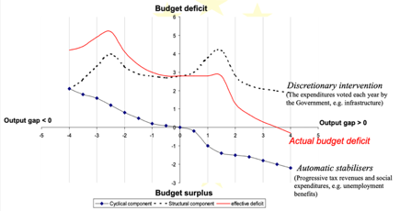  The political business cycle or the same form of Gov, parliamentary vs. presidential can lead a Gov to generate excessive deficits, even in positive phases of the cycle (eu since 1960).  Automatic stabilizers: u benefits, food stamps, and the personal and corporate income tax. They make expenditure raise a lot during recessions (safety nets enter in force)  Ensure cohordinaiton between a centralised mp and de-centralised nat fp  Achieve solid budgetary discipline and maintain it  Objectives:  Maastricht Treaty:  If a 0 deficit was required, this means that at the natural level of growth you would have had no room for capital investments (LT I)  States that “member States shall avoid excessive government deficits”. Two specific fiscal provisions:  I. Deficit/GDP below 3%,  II. debt/GDP below (or converging to) 60%  + The Treaty contains also an excessive deficit procedure to enforce these provisions (see infra)  60% is the stable level of debt coherent with a 3% deficit when nomimal g is 5 (2% π target + 3% GDP growth). This comes the formula for debt sunstainabiliy. Note: contested, many suggest 90%  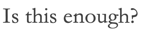  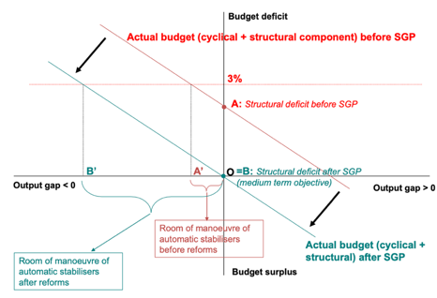  If we fix a 3% deficit threshold and countries stay around that threshold in the MT (i.e. at zero output gap), target will be exceded as automatic stabilizers come into force! = We need further rules  SGP:  Stability and Growth Pact to ‘oblige’ countries to achieve a balanced m-t budget target (MTO)*. Stability progreammes describe the adjustment path of budget deficits towards the Medium-Term Objective . Why 0?  Research: The functioning of automatic stabilizers would have never taken the deficit above 3% of GDP starting from balanced deficit (i.e. no deficit at potential output level with no inflationary pressure). However, this does not apply to large recessions (exceptions)  *MTO of budgetary positions is differentiated by MS (from -1% to surplus) and defined in structural terms: filter out business cycle swings and the effects of one-off temporary measures / deep reforms (such as labor mkt reforms, policies to foster R&D and innovation, pension reforms) + possibly other relevant things. Politics: convince EU the deficit is not structural! = room for political compromise with danger of ambiguous interpretations  Non-automatic waivers can also be granted if thee a period of negative growth rate, or from the accumulated loss of output during a protracted period of very low growth relative to potential growth.  Temporary waiver can be granted if the growth rate of a country falls by 0.75 to 2%  Automatic exceptions if the growth rate of a country falls by at least 2%;  If fails to abide by either the preventive or the corrective rules: fine of 0.2% of GDP.  If repeatedly fails to abide by the corrective rules fone of 0.5% of GDP  Country obliged to take all the necessary measures to comply with the SGP within the time horizon defined in the procedure  ECOFIN Council vote*  EC proposes excessive deficit procedure  *After the introduction of the SGP in 1997, the Commission requested to the EcoFin Council the activation of several excessive deficit procedures since 2002. But these requests were not always effective, as govs in the Council “colluded in a repeated game” (abstensions). The Commission then appealed to ECJ, which ruled against the EcoFn Council. The European Council then intervened, and ‘encouraged’ the EC to propose a reform of the SGP able to gove more flexibility to the Council with the introduction of a number of discretional waivers / exceptions.  Now: The SGP has been suspended over the Covid-19 crisis  Since the seminal work of Mundell (1961), we know that a region can be considered as an Optimal Currency Area if:  Product and labor markets are integrated. <= produce where conditions are better Yes  Prices and wages are perfectly flexible across the area <= mobily of workers Yes  Fiscal policies are able to cope with asymmetric shocks eventually hitting the area <= Yes  The business cycles are perfectly synchronized, in order to ensure an optimal conduct of the centralized monetary policy  Need Convergence criteria to synchronize business cycles:  Condition Idea is that even if currently is not completely true it will become true, as mp is cohordinated  π < avg of the 3 EU c with lowest π +1.5%  2 Maastricht Fiscal criteria  Nat currencies must not have been devalued and must have remained in the 15% bands of the EMS for the previous 2 yrs  Lt i < avg of the 3 EU c with lowest i + 2%  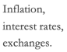  Signals on where you are in the business cycle  6. Results of EMU  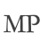  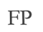  Convergence in π  Convergence in public debt? Avg 69% as in previous decade  -Yes, Ger, Net, Fra converged to 60 from the bottom.  - Decreasing in high debt countries. Note Ita let in as starded reducing debts (some painful yrs of fiscal adjustment 125 -> 118 ), then stopped.  Convergence in i (except Uk, followes more US business cycle, not in €, not in ERM).  Avg deficit/GDP in 1999-2008 has been 1.7% (critical 3%), below 4.3% of 1989-1999 = it seems that the SGP has been effective, although the upturn in cycle has helped. But what is driving this deficit reduction?  Expenditure/GDP = Primary expenditure/GDP (what you spend structurally) + Interest payment/GDP:  In the most indebted countries the deficit reduction has happened only thanks to lower interest payments thanks to declining interest rates (thanks to the Euro), and not through a structural reduction of expenditure... Super dangerous as it hides problems!  Note: Some countries have managed to reduce the tax burden (lower T revenue), others no ex. Ita and Greece  Nice: ECB refi rate (MRO) followed closely the policy rate until the crisis, but then diverged  Nice: ECB established a strong reputation of commitment to price stability. Core inflation and expectations anchored to 2%, low volatility  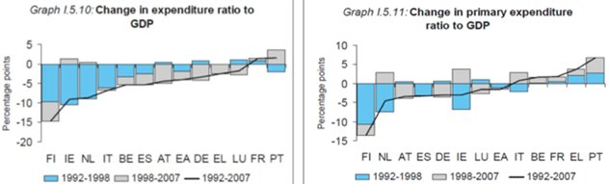  Evidence on gdp growth:  Neutral: 2.1% avg. GDP growth for 1999-2008, same as 1989-1999 (2.2%), less than 2.6% of US. Heterogeneous picture across member States:  - small countries have grown more  - 2 big economies have slowed down: Germany (from 2.5% to 1.5%) and Italy (around 1.5%).  Reasoning  Why? GDP growth can be decomposed in employment growth and labor prod growth.  - Employment growth has been high: 1.3% against 0.6% in previous decade (and 1% in US).  Due to: labor market reforms, shift to labor intensive services and wage moderation due to higher competition (Single Market + Globalization).  - Labor productivity growth has been very low: 0.8% against 1.6% in previous decade (and 1.6% in US). Due to: low R&D, low productivity in services, low ICT adoption, bad management (horizontal managerial structure (US) better than hierarchical to chatch innovation), not enough competitive pressures / market integration (i.e. without the euro it could arguably have been worse: lack of productivity growth is concentrated in the service sector, the less integrated!).  